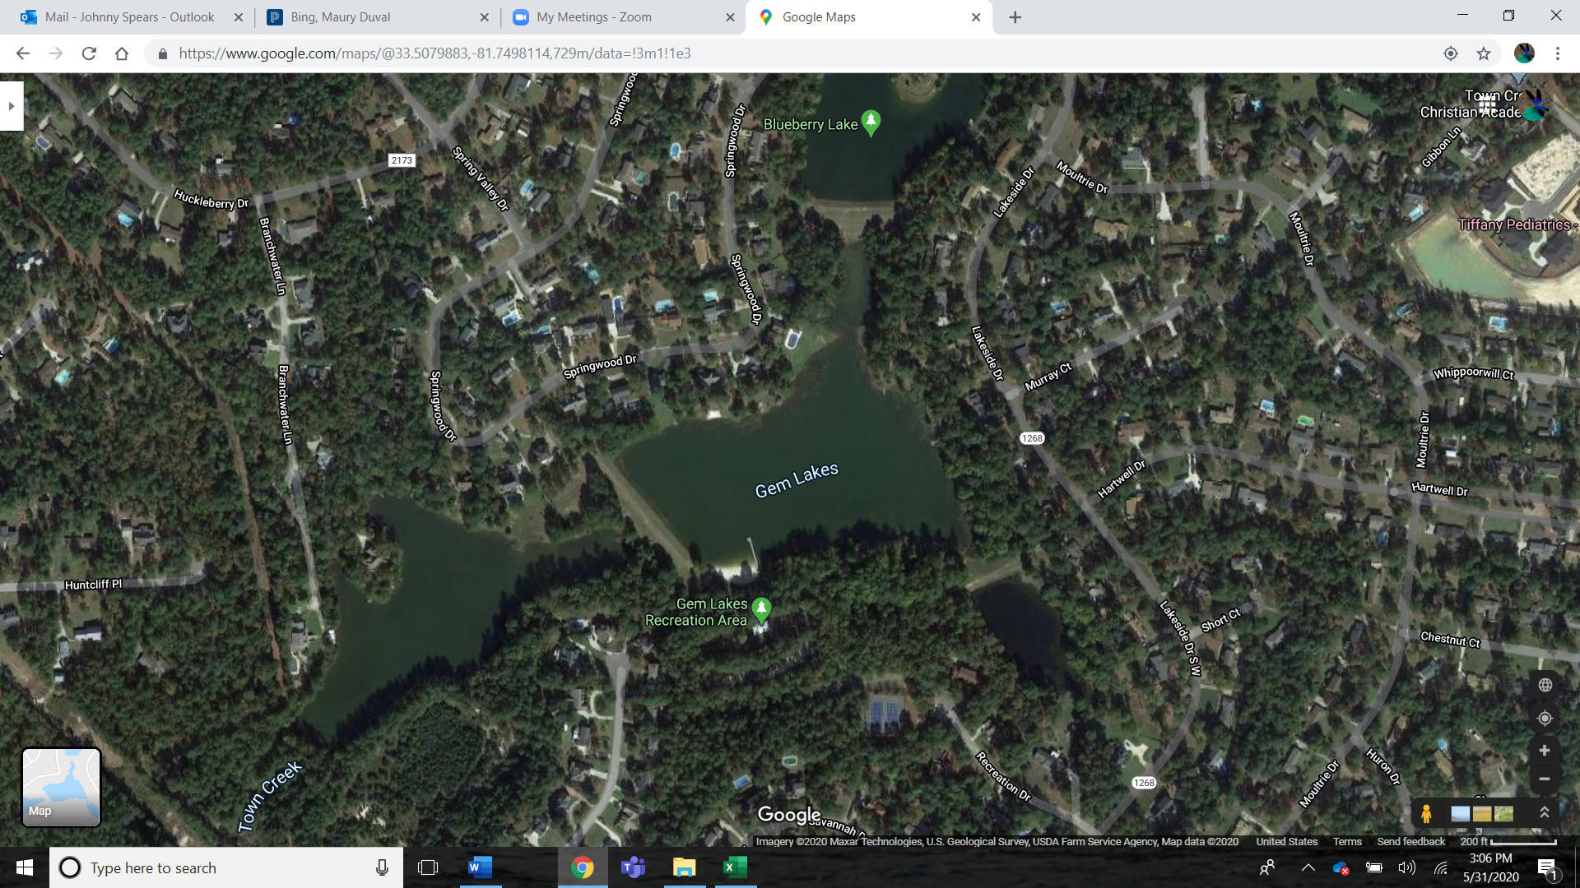

Springwood Drive path across Blueberry Lake

Springwood Drive path across Blueberry Lake

Lakeside Drive walk in entrance

Springwood Drive Walk In Entrance to Recreation Area

Main Entrance to Recreation Area and Tennis Courts